Final Project Report: Strategic Employee Attrition Analysis

Introduction
  - Project overviews: This project utilizes analytical tracking to investigate why employees are voluntarily resigning from the company. By evaluating key operational indicators, this initiative transitions the business from a reactive state to proactive talent retention planning.
  - Objectives: To isolate the top drivers behind employee turnover, track risk metrics across different corporate job categories, and supply the HR department with data-backed retention strategies.

Project Initialization and Planning Phase
  - Define Problem Statement: Rising workforce turnover is driving up recruitment expenses, causing sudden losses in institutional workflow speed, and reducing morale. The core workplace factors behind these departures are currently unmeasured and unverified.
  - Project Proposal (Proposed Solution): Designing and implementing an interactive HR Analytics Dashboard that processes historical workforce records to identify structural turnover vulnerabilities and pinpoint high-risk employee segments.
  - Initial Project Planning: Arranging an agile 4-week delivery strategy covering data ingestion, record cleansing, metric calculations, report construction, dashboard layout design, and deployment.

Data Collection and Preprocessing Phase
  - Data Collection Plan and Raw Data Sources Identified: Exported operational dataset from the core Human Resources Information System (HRIS) database including metrics such as Monthly Income, Role, Age, Overtime tracking, Satisfaction values, and Attrition status.
  - Data Quality Report: Evaluated incoming files for completeness, handled empty fields using median data imputation methods, and corrected structural name variations across operational units.

  - Data Exploration and Preprocessing: Converted categorical binary fields like Attrition (Yes/No) into standard numerical flags (1/0) to enable swift calculation tracking.

Data Visualization
  - Framing Business Questions: Which specific departments experience the highest departure rates? Does overtime workload correlate with low satisfaction trends? Is there a identifiable retention risk timeline across job tenures?
  - Developing Visualizations: Built targeted donut charts for overall distribution tracking, grouped bar charts for overtime evaluation, and multi-variable scatter plot maps related income tiers with individual performance.

Dashboard

Dashboard Design Screenshot with Insights
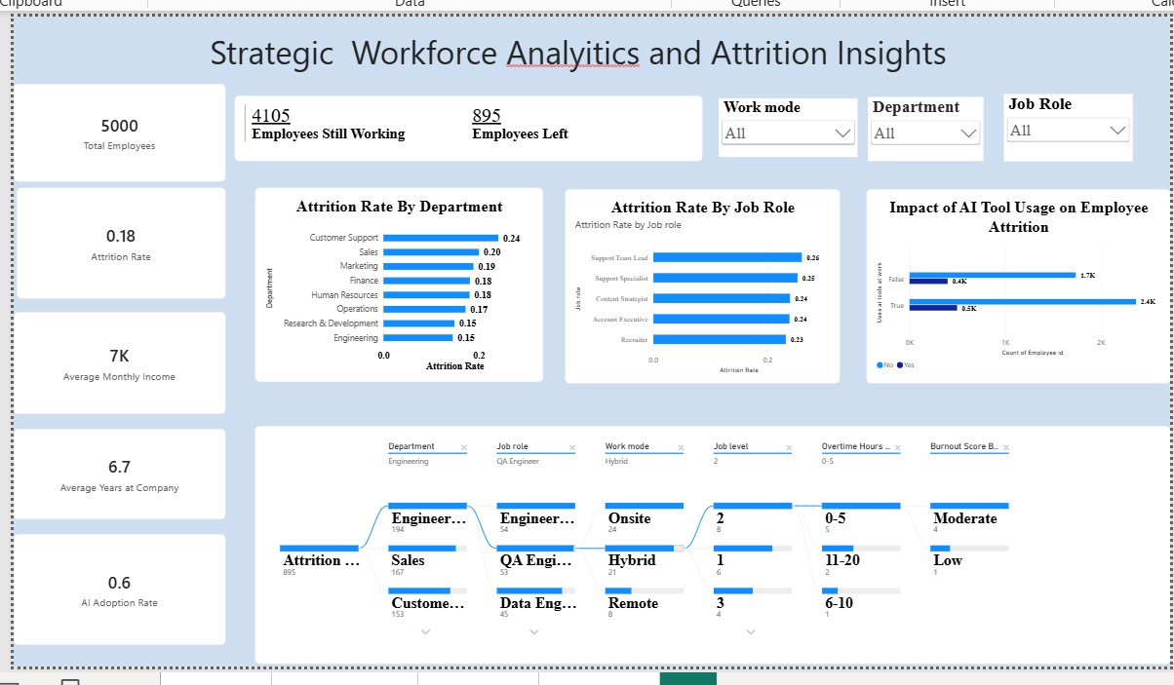

Key Insights:
Overtime Impact: Workers handling regular overtime hours exhibit a turnover rate roughly double that of non-overtime teams.
Department Vulnerability: Voluntary turnover is highly concentrated in the Research and Development (R&D) and Sales departments.

Tenure Risk: Employees within their initial 2 years of tenure are at the highest statistical risk for voluntary exit.

Report

6.1: Report Design Screenshot with Insights
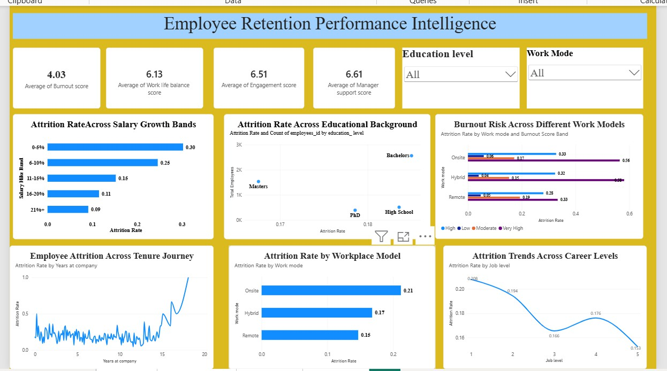

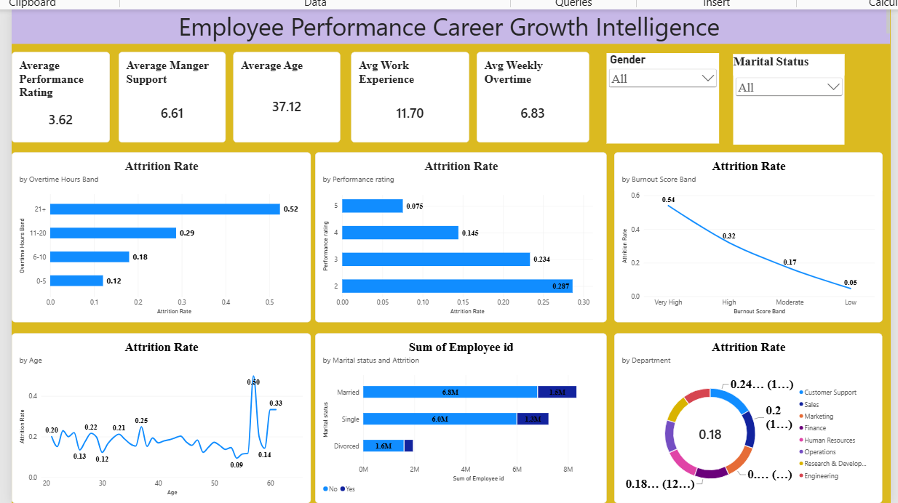

Key Insights:
Satisfaction Triggers: Drop-offs in environment and job satisfaction ratings serve as strong leading indicators of upcoming employee attrition.
Career Growth: Employees holding the exact same role for over 3 years without structural promotions show an immediate spike in exit likelihood.

Performance Testing
  - Utilization of Data Filters: Integrated cross-visual global filters for Department,Job Role, and Gender to allow real-time dashboard across filtering.
  - Number of Calculation Columns/Measures: Coded 10 target analytical measures including Attrition Rate %, Average Monthly Earnings and Total Headcount.
  - Number of Visualizations: Deployed a total of 8 active canvas assets for clean,data-driven workforce tracking.

Conclusion
The analytical framework proves that work-life balance imbalances (driven by overwork) and compensation stagnation are the primary catalysts of company turnover. Addressing these localized segments will directly protect the workforce.

- Future Scope: Deploying an embedded machine learning classification pipeline to calculate and display automated attrition risk probabilities directly inside quarterly human resource profiles.

Appendix

10.1 Source code (if any)
SQL query script used to format core workforce attrition data
SELECT EmployeID, Age, Department, Job Role, Monthly Income, YearsAtCompany, YearsSinceLastPromotion,
CASE WHEN Attrition =’Yes’ THEN 1
ELSE 0 END AS IsAttrited,
CASE WHEN Overtime=’Yes’ THEN 1
ELSE 0 AND AS WorkOverTime FROM HR_Analytics_Database.db.Employee_Records
WHERE EmploymentStatus=’Active’ OR SeparationYear>=2025;
Use code with caution.
10.2. Github and Project Demo Link GitHub Repository: https://github.com/sandhyaragi7/Strategic-Employee-Attrition-Intelligence-Dashboard
Demo Link:

https://drive.google.com/file/d/18WIaZE_mh8CsLyS2LcdcK2MaXs_g57hb/view?usp= drivesdk

